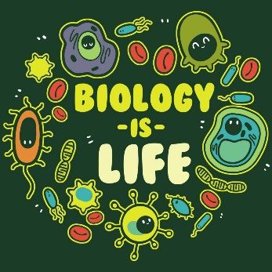
Biology Syllabus

Lindsay Presnell

Room: 201
E-mail address: lpresnell@amherst.12.va.us
School phone: (434) 528-6499 Ext. 30855

Course Description:
Throughout laboratory work, students will discover the parts and processes of living things and their interactions with each other. Representative organisms from the six kingdoms are examined and unifying concepts such as cell structure, genetics, evolution, reproduction, and life characteristics are explored. The course gives students a better understanding of their physical selves and the world around them. This is an SOL course and the SOL test will be administered at the end of the course.

Course Objectives:
Students will investigate and demonstrate understanding of:
Scientific Investigation Evolution
Biochemistry Kingdoms/Classification
Cell Physiology Ecology
Genetics

Grades and Grading:
You will receive a grade in Biology based on the percentage of points earned out of total points possible. These points will come from labs, quizzes, tests, classwork and Canvas work. You will do well in class if you complete and actively participate in your assignments. It is your responsibility to check your grades online in PowerSchool. The grading policy for the year is shown below:
Mastery of Content (quizzes, tests, etc.) 60%
Measure of Progress (classwork, labs, etc.) 40%

Student Expectations: For us to have a successful year together, you should know what I expect of you. I think you will find that most of these things are common sense!

-Treat your teacher, each other, and materials with respect.
-Follow directions and lab safety rules carefully.
-Be prepared for class (bring on time, bring all materials, etc.)
-All student handbook rules will be enforced (tardies, cell phones, food/drink, etc.)
-Respect other students’ right to learn, the teacher’s right to teach, and the classroom and
personal property.

Need Extra Help?
If you need help, I am always quick to reply to emails/phone calls or can even schedule a parent/teacher conference or Google Meet. I am also available before school or sometimes after school, but please talk to me and schedule a specific time so I can plan my day accordingly.
Attendance:
Attendance is extremely important. During face-to-face classes at school, students are expected to arrive in class on time and ready to learn. Restrooms or any other errands should be done during class changes or at lunch. If you are absent for any length of time you will be expected to log in to Canvas each day and complete the daily assignments.

Materials Needed:
- Charged Chromebook
- Ear buds/Headphones
- Pencil/Pen
- 3 ring binder
- Colored Pencils (optional)

If you have any questions at all, please do not hesitate to ask! I am looking forward to this year and hope you are too!

